University of Waterloo

Faculty of Engineering

Department of Computer and Electrical Engineering

Initial Prototype Demonstration and Progress Report

Voice - Device to Enable Real-time Sign Language to Speech Translation

Group 2017.037

Akshay Budhkar (20457593)

Eliot Chan (20462016)

Biraj Kapadia (20467909)

Amish Patel (20460828)

Consultant: Prof. Dana Kulić

July 26, 2016



Table of Contents

1 Overview of the Project 1

1.1 Revised Project Abstract 1

1.2 Original Project Timeline 1

2 Current Status of the Project 2

2.1 Prototype Completion 2

2.2 Student Hours 2

3 Discussion 3

4 Appendix A: Student Logs 4

# Overview of the Project

## Revised Project Abstract

There are 375,000 culturally deaf people in Canada, and in-person communication barriers between the native sign language speakers and the general populous still remain high. Many people do not understand sign language, and communicating through a text medium is arduous and impersonal. The goal of this project is to design a device to translate sign language to speech in real-time, allowing the deaf or mute to communicate naturally even with those who do not know sign language. Voice uses custom-made ergonomic gloves equipped with various sensors and an onboard microcontroller to track and stream data on a user's hand positions and motions to a Bluetooth-connected mobile application. The application connects to a quorum of pre-trained machine learning models to predict the given sign and speak it aloud, mimicking true speech. Our system can match tens of American Sign Language signs, in addition to signs for the Japanese manual syllabary. Voice is portable and unobtrusive compared to current computer vision variants - requiring the minimum of hardware - giving users a voice that they never had.

## Original Project Timeline

Given that all four team members are working in downtown Toronto for the Fall 2016 term, the team can continue working on the project at a highly reduced intensity (approximately one to two hours per week, on average). As such, the project timeline will span the co-op term in addition to both 4A and 4B academic terms.

The project is broken down into two major phases and four major tasks. Phase one of the project will be done throughout the 4A term and phase two of the project will be carried out during the final co-op term and 4B. Figure 1 and Figure 2 illustrate our timeline during the two phases along with the time allocated to each group of tasks. Time allocated to designing and building the external subsystem prototype is in red. Any time allocated towards machine learning tasks are in green, and any tasks related to the companion mobile application are in yellow. Finally, other miscellaneous tasks are shown in blue.

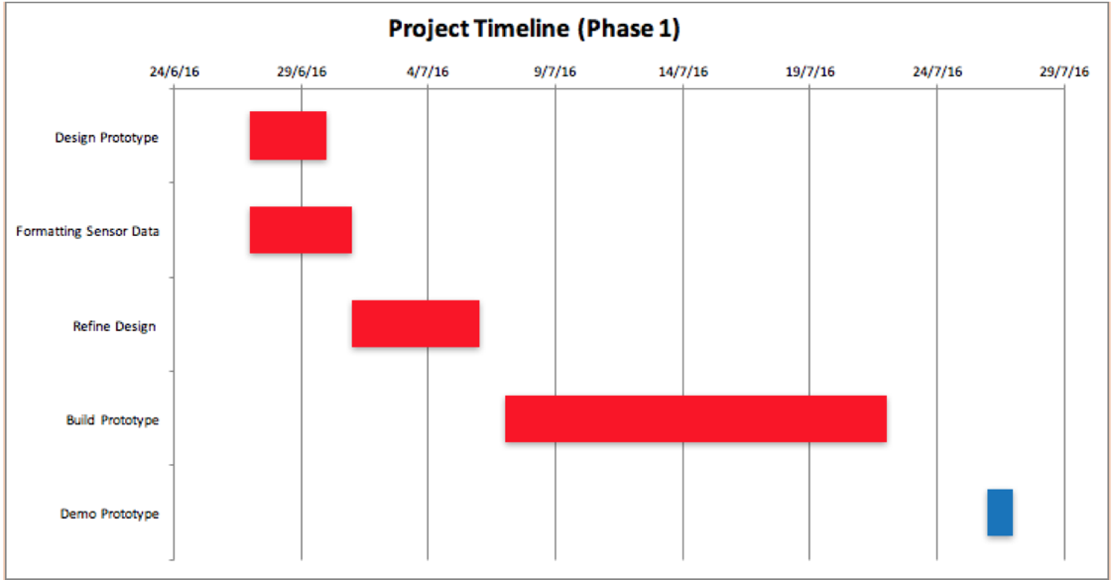

*Figure 1: Phase One Gantt Chart (June 27th to July 27th)*

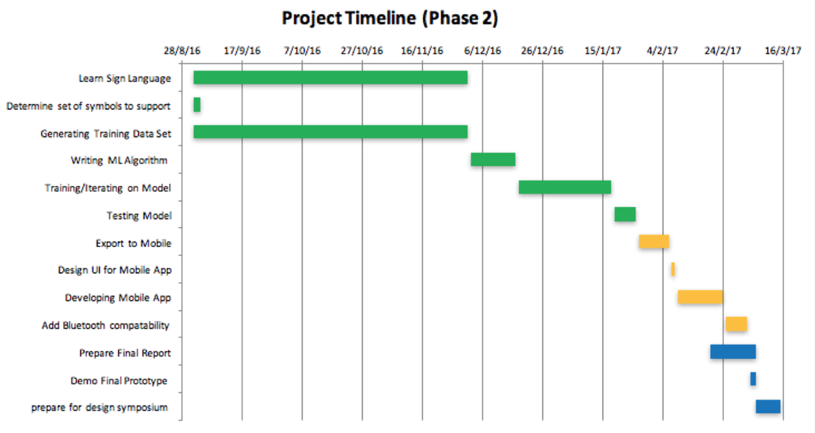

*Figure 2: Phase Two Gantt Chart (September 1st to March 15th)*

# Current Status of the Project

## Prototype Completion

The group has completed approximately 70% of the entire project. Our initial glove prototype is now able to gather relevant data when a user is making a sign and transmit this data through an Arduino, and further, to an Android application using a Bluetooth adapter. This application forwards this data to a Python backend which has incorporated a Machine Learning model that has been trained offline for two signs - “Hello” and “Bye”. The backend responds with the predicted sign, based on its classification of the the user’s motion/finger position, etc. as the input data. The Android application receives this prediction, updates the transcript, and speaks the sign aloud, completing the entire flow through all of Voice’s subsystems.

All of the subsystems work independently of each other, and work together when integrated. The largest next step is for the team members to create/gather hand motion/position data for the signs Voice has been specified to support. This data will be used to re-train the models. We will also be working on refining the overall design of the glove, and powering it using an external battery pack.

## Student Hours

Table 1. Hours worked by students (Appendix A)

|  |  |
| --- | --- |
| Student | Hours |
| Akshay Budhkar | 107 |
| Eliot Chan | 88.75 |
| Biraj Kapadia | 93.75 |
| Amish Patel | 103 |
| Total Hours | 392.5 |

The total number of hours spent on the project was 392.5 (Table 1). It was difficult in the first few weeks to work on the hardware components as we were waiting for parts to arrive in the mail. Because of this, we were blocked on some portions of the other subsystems, and as such, the majority of the work was completed in July.

Despite spending less time than the recommended number of hours, the project is still well on its way and the team is quite confident in its completion by the Design Symposium.

# Discussion

The group is quite confident that we can complete all essential specifications except perhaps the number of signs supported. Since all of the individual subsystems have been tested as working while integrated, the majority of the remaining work is related to training the machine learning models to support more signs, and to predict them more accurately.

If we find that our models are unable to predict the number of signs correctly or accurately, we can reduce the number of signs in scope. The team has worked quite well together so far, and there are no doubts about our continued ability to function and contribute to the project.

# Appendix A: Student Logs

|  |  |  |  |  |  |
| --- | --- | --- | --- | --- | --- |
| **Name: Amish Patel                   Group: 037                         Signature:** | | | | | |
| By signing above, I am stating that this is an accurate account of the tasks, dates, and times that I worked on my capstone design project. | | | | | |
| **Date** | **Task** | **Time (hours)** | **Start Time** | **End Time** | **Running Total** |
| 5/11/2016 | Brainstorming Ideas | 3.5 | 1:00 PM | 4:30 PM | 3.5 |
| 5/12/2016 | Researching Ideas | 2.5 | 12:00 PM | 2:30 PM | 6 |
| 5/14/2016 | Finalizing Abstract draft and researching on potential consultants | 4 | 8:00 PM | 12:00 AM | 10 |
| 5/17/2016 | Meeting with Potential Consultants | 1.5 | 2:00 PM | 3:30 PM | 11.5 |
| 5/18/2016 | Weekly Team Meeting | 1.5 | 8:00 PM | 9:30 PM | 13 |
| 5/25/2016 | Weekly Team Meeting | 1.5 | 8:00 PM | 9:30 PM | 14.5 |
| 5/26/2016 | Brainstorming Project Specifications and coming up with block diagram draft | 2 | 7:10 PM | 9:10 PM | 16.5 |
| 5/27/2016 | Apply for the Engineers for Trust Scholarship | 1 | 8:30 PM | 9:30 PM | 17.5 |
| 5/29/2016 | Finalize Project Specifications and Risk Management Document | 4 | 4:45 PM | 8:45 PM | 21.5 |
| 6/1/2016 | Weekly Team Meeting | 1.5 | 8:00 PM | 9:30 PM | 23 |
| 6/7/2016 | Getting the project timeline | 2.5 | 5:45 PM | 8:15 PM | 25.5 |
| 6/8/2016 | Weekly Team Meeting | 1.5 | 8:00 PM | 9:30 PM | 27 |
| 6/8/2016 | Finalizing on the Baylis Pitch | 1.75 | 9:45 PM | 10:30 PM | 28.75 |
| 6/9/2016 | Coming up with answers to potential questions for Baylis Pitch | 1.5 | 2:45 PM | 4:15 PM | 30.25 |
| 6/9/2016 | Refining the pitch+potential questions after Prof. Dana's review | 0.5 | 6:30 PM | 7:00 PM | 30.75 |
| 6/15/2016 | Weekly Team Meeting | 1.5 | 8:00 PM | 9:30 PM | 32.25 |
| 6/16/2016 | Experimenting and looking up with sensors | 2 | 1:15 PM | 3:15 PM | 34.25 |
| 6/19/2016 | Learning Machine Learning - Day 1 | 1.5 | 3:00 PM | 4:30 PM | 35.75 |
| 6/22/2016 | Experimenting with Accelometer/Gyroscope Sensor + Arduino | 1.75 | 6:30 PM | 8:15 PM | 37.5 |
| 6/22/2016 | Weekly Team Meeting | 1.5 | 8:00 PM | 9:30 PM | 39 |
| 6/23/2016 | Reading Flora sensor data + looking on tutorials for Android-Arduino communication | 2.5 | 1:30 PM | 4:00 PM | 41.5 |
| 6/25/2016 | Started working on detailed design + gathering data from sensors | 4 | 2:15 PM | 6:15 PM | 45.5 |
| 6/25/2016 | Gathering data from flex sensors and accelerometer/gyroscope | 4 | 7:15 PM | 11:15 PM | 49.5 |
| 6/26/2016 | Working on the detailed design | 5.25 | 2:15 PM | 7:15 PM | 54.75 |
| 6/26/2016 | Working on the detailed design | 2 | 8:00 PM | 10:00 PM | 56.75 |
| 6/28/2016 | Fix up the detail design report based on Prof. Kulić's feedback | 4 | 5:00 PM | 9:00 PM | 60.75 |
| 6/29/2016 | Weekly Team Meeting | 1.5 | 8:00 PM | 9:30 PM | 62.25 |
| 7/6/2016 | Weekly Team Meeting | 1.5 | 8:00 PM | 9:30 PM | 63.75 |
| 7/10/2016 | Planning on what tasks need to be done by the demo date | 1 | 12:15 PM | 1:15 PM | 64.75 |
| 7/10/2016 | Create and initialize android application repository | 0.5 | 4:00 PM | 4:30 PM | 65.25 |
| 7/10/2016 | Android Development: Implemented the UI portion of the application | 3 | 5:00 PM | 8:00 PM | 68.25 |
| 7/13/2016 | Android Development: Incorporate TextToSpeech module to the application | 2 | 3:30 PM | 5:30 PM | 70.25 |
| 7/13/2016 | Weekly Team Meeting | 1.5 | 8:00 PM | 9:30 PM | 71.75 |
| 7/14/2016 | Android Development: Implement the Export to txt option + UI Listeners and Initialization | 4 | 11:00 PM | 3:00 PM | 75.75 |
| 7/15/2016 | Designing the Glove: Stitching pockets on them for flex sensors - Helping my Mother with directions | 2 | 4:00 PM | 6:00 PM | 77.75 |
| 7/16/2016 | Android Development: Implement Simulation where a stream of data is sent to the transcript | 3 | 9:00 PM | 12:00 PM | 80.75 |
| 7/18/2016 | Bluetooth Integration: Making sure we get "Hello World" running for Android-Arduino communication | 2.5 | 2:15 PM | 4:45 PM | 83.25 |
| 7/18/2016 | Bluetooth Integration: Getting data from arduino through bluetooth | 1.75 | 6:00 PM | 7:45 PM | 85 |
| 7/20/2016 | Android Development: Working on client-server communication through sockets | 2 | 5:30 PM | 7:30 PM | 87 |
| 7/20/2016 | Weekly Team Meeting | 1.5 | 8:00 PM | 9:30 PM | 88.5 |
| 7/22/2016 | Soldering sensors+arduino for the first glove | 3.5 | 11:30 AM | 3:00 PM | 92 |
| 7/22/2016 | Soldering sensors+arduino for the first glove | 3 | 3:40 PM | 6:40 PM | 95 |
| 7/23/2016 | Assembling the Gloves | 2.5 | 9:00 PM | 11:30 PM | 97.5 |
| 7/24/2016 | Android Development: Bridging the Arduino code with server | 3.5 | 2:00 PM | 5:00 PM | 101 |
| 7/25/2016 | Demo | 1 | 11:30 AM | 12:30 PM | 102 |
| 7/25/2016 | Work on the Progress Report | 1 | 8:40 PM | 9:40 PM | 103 |

|  |  |  |  |  |  |
| --- | --- | --- | --- | --- | --- |
| **ECE498A:  Student Log** | | | | | |
| **Name:    Biraj Kapadia                                Group:            037                       Signature:                                  .**  **By signing above, I am stating that this is an accurate account of the tasks, dates, and times that I worked on my capstone design project.** | | | | | |
| **Task** | **Date** | **Start time** | **Finish time** | **Hours** | **Running total of hours** |
| Brainstorming Ideas | May 11 | 01:00 PM | 04:30 PM | 3.5 | 3.5 |
| Research/Narrowing Ideas | May 12 | 12:00 PM | 02:30 PM | 2.5 | 6 |
| Research Consultant/Finish Abstract | May 14 | 08:00 PM | 12:00 PM | 2 | 8 |
| Talk to Consultants | May 16 | 01:00 PM | 02:45 PM | 1.75 | 9.75 |
| Finalize Consultants | May 17 | 04:00 PM | 04:15 PM | 0.25 | 10 |
| Team Meeting | May 18 | 08:00 PM | 09:30 PM | 1.5 | 11.5 |
| Apply for Baylis medical award | May 20 | 11:15 AM | 11:45 AM | 0.5 | 12 |
| Discuss and write specs | May 24 | 05:30 PM | 07:30 PM | 2 | 14 |
| Team Meeting | May 25 | 08:00 PM | 09:00 PM | 1.5 | 15.5 |
| Prepare info for other award applications | May 28 | 09:15 PM | 10:00 PM | 0.75 | 16.25 |
| Finish Award Application and Specs Document | May 29 | 04:00 PM | 06:45 PM | 2.75 | 19 |
| Team Meeting | June 1 | 08:00 PM | 09:30 PM | 1.5 | 20.5 |
| Discuss goals for first iteration | June 7 | 05:45 PM | 08:15 PM | 2.5 | 23 |
| Team Meeting | June 8 | 08:00 PM | 09:30 PM | 1.5 | 24.5 |
| Discuss the pitch for Baylis award | June 8 | 09:30 PM | 11:30 PM | 2 | 26.5 |
| Discuss the design | June 9 | 02:30 PM | 04:00 PM | 1.5 | 28 |
| Get parts for prototyping | June 10 | 01:00 PM | 01:15 PM | 0.25 | 28.25 |
| Testing parts | June 11 | 03:00 PM | 04:00 PM | 1 | 29.25 |
| Team Meeting | June 15 | 08:00 PM | 09:30 PM | 1.5 | 30.75 |
| Arduino Test | June 22 | 06:30 PM | 08:00 PM | 1.5 | 32.25 |
| Team Meeting | June 22 | 08:00 PM | 09:30 PM | 1.5 | 33.75 |
| Arduino Test | June 23 | 01:30 PM | 04:00 PM | 2.5 | 36.25 |
| Detailed Design | June 25 | 02:30 PM | 06:30 PM | 4 | 40.25 |
| Arduino Test | June 25 | 07:15 PM | 11:15 PM | 4 | 44.25 |
| Detailed Design | June 26 | 02:00 PM | 07:00 PM | 5 | 49.25 |
| Detailed Design | June 26 | 08:00 PM | 10:00 PM | 2 | 51.25 |
| Detailed Design | June 29 | 02:30 PM | 04:00 PM | 1.5 | 52.75 |
| Weekly Team Meeting | June 29 | 08:00 PM | 09:30 PM | 1.5 | 54.75 |
| Detailed Design | June 29 | 09:30 PM | 11:00 PM | 1.5 | 55.75 |
| Weekly Team Meeting | July 6 | 08:00 PM | 09:30 PM | 1.5 | 57.25 |
| Discuss Parts to we need for the initial prototype | July 10 | 12:30 PM | 01:30 PM | 1 | 58.25 |
| Team Meeting | July 13 | 08:00 PM | 09:30 PM | 1.5 | 59.75 |
| Help debug issues with parsing the data used to generate the ML model | July 15 | 02:15 PM | 04:15 PM | 2 | 61.75 |
| Work on Arduino and research missing parts for next week | July 16 | 01:30 PM | 05:15 PM | 3.75 | 65.5 |
| Research on how to send data from Arduino HC-06 to Android devices via Bluetooth | July 16 | 06:00 PM | 07:00 PM | 1 | 66.5 |
| Implement sending data from Arduino to Android phone | July 18 | 02:15 PM | 04:45 PM | 2.5 | 69 |
| Getting android to read Bluetooth data within the Application itself | July 18 | 06:00 PM | 07:45 PM | 1.75 | 70.75 |
| Team Meeting | July 20 | 08:00 PM | 09:30 PM | 1.5 | 72.25 |
| Implement the communication between HC-05 and HC-06 | July 21 | 05:30 PM | 08:45 PM | 3.25 | 75.5 |
| Implement the communication between HC-05 and HC-06 | July 21 | 09:30 PM | 11:59 PM | 2.5 | 78 |
| Implement the communication between HC-05 and HC-06 | July 22 | 12:00 AM | 02:00 AM | 2 | 80 |
| Soldering sensors + Arduino for the first glove | July 22 | 11:30 AM | 03:00 PM | 3.5 | 83.5 |
| Soldering sensors + Arduino for the first glove | July 22 | 03:40 PM | 06:40 PM | 3 | 86.5 |
| Assembling and test the first glove | July 23 | 09:00 PM | 11:30 PM | 2.5 | 89 |
| Integration Testing for the Demo | July 24 | 01:00 PM | 03:45 PM | 2.75 | 91.75 |
| Demo the initial prototype | July 25 | 11:30 PM | 12:30 PM | 1 | 92.75 |
| Work of Progress Report | July 25 | 08:40 PM | 09:40 PM | 1 | 93.75 |

|  |  |  |  |  |  |
| --- | --- | --- | --- | --- | --- |
| **ECE498A:  Student Log** | | | | | |
| **Name:    Akshay Budhkar                                Group:                037                       Signature:                                                    .**  **By signing above, I am stating that this is an accurate account of the tasks, dates, and times that I worked on my capstone design project.** | | | | | |
| Task | Date | Start time | Finish time | Hours | Running total of hours |
| Brainstorming Ideas | May 10 | 01:00 PM | 04:45 PM | 3.75 | 3.75 |
| Researching Ideas | May 11 | 1:00 PM | 4:30 PM | 3.5 | 7.25 |
| Research/Narrowing Ideas | May 12 | 12:00 PM | 02:30 PM | 2.5 | 9.75 |
| Research Consultant/Finish Abstract | May 14 | 08:00 PM | 12:00 PM | 2 | 11.75 |
| Talk to Consultants | May 16 | 01:00 PM | 02:45 PM | 1.75 | 13.5 |
| Finalize Consultants | May 17 | 04:00 PM | 04:15 PM | 0.25 | 13.75 |
| Weekly Team Meeting | May 18 | 8:00PM | 9:30 PM | 1.5 | 15.25 |
| Apply for Baylis medical award | May 20 | 11:15 AM | 11:45 AM | 0.5 | 15.75 |
| Discuss and write specs | May 24 | 05:30 PM | 07:30 PM | 2 | 17.75 |
| Weekly Team Meeting | May 25 | 8:00PM | 9:30 PM | 1.5 | 19.25 |
| Prepare info for other award applications | May 28 | 09:15 PM | 10:00 PM | 0.75 | 20 |
| Finish Award Application and Specs Document | May 29 | 04:00 PM | 06:45 PM | 2.75 | 22.75 |
| Weekly Team Meeting | June 1 | 8:00PM | 9:30 PM | 1.5 | 24.25 |
| Discuss goals for first iteration | June 7 | 05:45 PM | 08:15 PM | 2.5 | 26.75 |
| Weekly Team Meeting | June 8 | 8:00PM | 9:30 PM | 1.5 | 28.25 |
| Discuss the pitch for Baylis award | June 8 | 09:30 PM | 11:00 PM | 1.5 | 29.75 |
| Discuss the design | June 9 | 02:30 PM | 04:00 PM | 1.5 | 31.25 |
| Get parts for prototyping | June 10 | 01:00 PM | 01:15 PM | 0.25 | 31.5 |
| Testing parts | June 11 | 03:00 PM | 04:00 PM | 1 | 32.5 |
| Weekly Team Meeting | June 15 | 8:00PM | 9:30 PM | 1.5 | 34 |
| Arduino Test | June 22 | 06:30 PM | 08:00 PM | 1.5 | 35.5 |
| Weekly Team Meeting | June 22 | 8:00PM | 9:30 PM | 1.5 | 37 |
| Arduino Test | June 23 | 01:30 PM | 04:00 PM | 2.5 | 39.5 |
| Detailed Design | June 25 | 02:30 PM | 06:30 PM | 4 | 43.5 |
| Arduino Test | June 25 | 07:15 PM | 11:15 PM | 4 | 47.5 |
| Detailed Design | June 26 | 01:00 PM | 07:00 PM | 6 | 53.5 |
| Detailed Design | June 26 | 08:00 PM | 10:00 PM | 2 | 55.5 |
| Detailed Design | June 29 | 12:30 PM | 04:00 PM | 4.5 | 60 |
| Weekly Team Meeting | June 29 | 8:00PM | 9:30 PM | 1.5 | 61.5 |
| Weekly Team Meeting | July 6 | 8:00PM | 9:30 PM | 1.5 | 63 |
| Initial Prototype | July 10 | 12:00 | 1:30 | 1.5 | 64.5 |
| Weekly Team Meeting | July 13 | 8:00PM | 9:30 PM | 1.5 | 66 |
| ML-Initial Prototype | July 14 | 12:00 | 5:00 PM | 5 | 71 |
| ML-Initial Prototype | July 15 | 12:00 | 6:00 | 6 | 77 |
| ML- Preprocessing | July 16 | 1:00 | 7:30 | 6.5 | 83.5 |
| ML – Preprocessing | July 17 | 1:00 | 3:30 | 2.5 | 86 |
| ML – Model building | July 18 | 3:00 | 9:00 | 6 | 92 |
| ML – Backend setup | July 19 | 3:00 | 5:30 | 2.5 | 94.5 |
| Weekly Team Meeting | July 20 | 8:00PM | 9:30 PM | 1.5 | 96 |
| ML – Backend Preprocessing | July 21 | 10:00 | 2:30 | 4.5 | 100.5 |
| Integration | July 22 | 12:00 | 1:30 | 1.5 | 102 |
| Integration | July 24 | 2:00 | 5:00 | 3 | 105 |
| Demo | July 25 | 11:30 | 12:30 | 1 | 106 |
| Progress Report | July 25 | 8:40 | 9:40 | 1 | 107 |

|  |  |  |  |  |  |
| --- | --- | --- | --- | --- | --- |
| ECE498A:  Student Log | | | | | |
| Name:          Eliot Chan                    Group:              037                Signature:                                                    .  By signing above, I am stating that this is an accurate account of the tasks, dates, and times that I worked on my capstone design project. | | | | | |
| Task | Date | Start time | Finish time | Hours | Running total of hours |
| Brainstorming Ideas | May 10 | 1:00 PM | 4:45 PM | 3.75 | 3.75 |
| Research/Narrowing Ideas | May 12 | 12:00 PM | 2:30 PM | 2.5 | 6.25 |
| Begin Abstract Draft | May 13 | 8:00 PM | 8:30 PM | 0.5 | 6.75 |
| Research Consultants/Finish Abstract | May 14 | 8:00 PM | 10:00 PM | 2 | 8.75 |
| Talk to Consultants | May 16 | 1:00 PM | 2:45 PM | 1.75 | 10.5 |
| Finalize Consultant | May 17 | 4:00 PM | 4:15 PM | 0.25 | 10.75 |
| Weekly Meeting | May 18 | 8:00 PM | 9:30 PM | 1.5 | 12.25 |
| Discuss and Write Specs | May 24 | 5:30 PM | 7:30 PM | 2 | 14.25 |
| Weekly Meeting | May 25 | 8:00 PM | 9:30 PM | 1.5 | 15.75 |
| Prepare Information for Award Application | May 28 | 9:00 PM | 9:45 PM | 0.75 | 16.5 |
| Finish Award Application and Specs Doc | May 29 | 4:00 PM | 6:45 PM | 2.75 | 19.25 |
| Weekly Meeting | June 1 | 8:00 PM | 9:30 PM | 1.5 | 20.75 |
| Discuss Goals for First Iteration and Write Pitch for Baylis | June 7 | 6:00 PM | 8:15 PM | 2.25 | 23 |
| Continue to Write Pitch for Baylis | June 8 | 2:00 PM | 2:30 PM | 0.5 | 23.5 |
| Weekly Meeting | June 8 | 8:00 PM | 9:30 PM | 1.5 | 25 |
| Continue to Write Pitch for Baylis | June 8 | 9:30 PM | 11:15 PM | 1.75 | 26.75 |
| Research how to Power Arduino with Batteries, Finish Baylis Pitch | June 9 | 2:30 PM | 4:45 PM | 2.25 | 29 |
| Modify Pitch to be One Slide | June 9 | 11:00 PM | 11:30 PM | 0.5 | 29.5 |
| Practice and Present Baylis Pitch | June 10 | 12:30 PM | 1:30 PM | 1 | 30.5 |
| Buy Parts and Start Preliminary Arduino Testing | June 10 | 3:30 PM | 4:30 PM | 1 | 31.5 |
| Weekly Meeting | June 15 | 8:00 PM | 9:30 PM | 1.5 | 33 |
| Testing Parts, Figuring Out Other Parts to Buy | June 16 | 1:00 PM | 3:15 PM | 2.25 | 35.25 |
| Attempting to Read from Flora Sensor | June 22 | 6:00 PM | 7:45 PM | 1.75 | 37 |
| Weekly Meeting | June 22 | 8:00 PM | 9:30 PM | 1.5 | 38.5 |
| Actually Managing to Read from Flora Sensor | June 23 | 1:30 PM | 4:00 PM | 2.5 | 41 |
| Working on Detailed Design Doc | June 25 | 1:15 PM | 6:15 PM | 5 | 46 |
| Gathering Data for Design Doc and Working Out How to Fulfill Specs | June 25 | 7:15 PM | 12:15 AM | 5 | 51 |
| Working on Detailed Design Doc | June 26 | 2:15 PM | 7:15 PM | 5 | 56 |
| Working on Detailed Design Doc | June 26 | 8:00 PM | 12:00 AM | 4 | 60 |
| Polishing 9DOF Explanation in Design Doc | June 29 | 4:00 PM | 6:30 PM | 2.5 | 62.5 |
| Weekly Meeting | June 29 | 8:00 PM | 9:30 PM | 1.5 | 64 |
| Weekly Meeting | July 6 | 8:00 PM | 9:30 PM | 1.5 | 63.5 |
| Researching Time Sync, Creating Demo Script | July 16 | 3:30 PM | 7:00 PM | 3.5 | 67 |
| Practice Sign Language | July 17 | 9:30 PM | 10:00 PM | 0.5 | 67.5 |
| Get Socket-IO Python Base Application Running on Heroku | July 18 | 3:30 PM | 5:00 PM | 1.5 | 69 |
| Apply to Norman Esch Award | July 18 | 8:05 PM | 8:20 PM | 0.25 | 69.25 |
| Practice Sign Language | July 19 | 8:00 PM | 9:30 PM | 0.5 | 69.75 |
| Get socket communication working between Android app and backend | July 20 | 3:30 PM | 7:30 PM | 4 | 74.75 |
| Weekly Meeting | July 20 | 8:00 PM | 9:30 PM | 1.5 | 76.25 |
| Practice Sign Language | July 21 | 10:00 AM | 10:30 AM | 0.5 | 76.75 |
| Ensure backend is using sockets and not HTTP, miscellaneous hardware help for actual glove | July 22 | 11:30 AM | 3:30 PM | 4 | 80.75 |
| Practice Sign Language | July 23 | 2:15 PM | 2:45 PM | 0.5 | 81.25 |
| Researching multiple Bluetooth slave connections, shooting part of demo video | July 23 | 10:00 PM | 11:00 PM | 1 | 81.25 |
| Miscellaneous glove help | July 24 | 2:00 PM | 4:30 PM | 3.5 | 85.75 |
| Demo | July 25 | 11:30 AM | 12:30 PM | 1 | 86.75 |
| Final Progress Report | July 25 | 8:15 PM | 10:15 PM | 2 | 88.75 |